CSA0501-DATABASE MANAGEMENT SYSTEMS
LAB EXPERIMENTS DATE: 23/08/2026
K.SARANYA(192424409)

EXPERIMENT 15 -- DCL COMMANDS – GRANT, REVOKE

AIM:
To learn how to use various DCL commands such as GRANT and REVOKE in the Flight Reservation System database.

DESCRIPTION:
Data Control Language (DCL) is used to control privileges in a database. GRANT is used to provide privileges to a user, while REVOKE is used to take back privileges from a user.

PROCEDURE:
1. Open MySQL Workbench and select the Flight_Reservation database.
2. Create a database user for demonstrating DCL commands.
3. Grant required privileges on the Flight_Reservation database to the user.
4. Verify the granted privileges.
5. Revoke a privilege from the user.
6. Verify the privileges again.

SYNTAX:
GRANT privilege ON database_name.* TO 'username'@'localhost';
REVOKE privilege ON database_name.* FROM 'username'@'localhost';

PROGRAM:
USE Flight_Reservation;
CREATE USER IF NOT EXISTS 'flight_user'@'localhost'
IDENTIFIED BY 'Flight@123';
GRANT SELECT, INSERT, UPDATE
ON Flight_Reservation.*
TO 'flight_user'@'localhost';
SHOW GRANTS FOR 'flight_user'@'localhost';
REVOKE INSERT
ON Flight_Reservation.*
FROM 'flight_user'@'localhost';
SHOW GRANTS FOR 'flight_user'@'localhost';
OUTPUT:

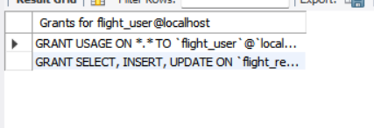

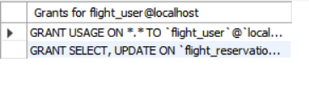

RESULT:
Thus, the DCL commands GRANT and REVOKE were successfully executed and the privileges were verified in the Flight Reservation System database.

